**JOBSHEET 2**

**Variables, Data Types, Operators and Input-Output**

1. **Objective**

* Students understand and explain Data Types in Java programming
* Students understand and explain variables in Java programming
* Students are able to explain input-output in Java programming
* Students understand and explain Operators in Java programming

1. **Laboratory**
   1. **Experiment 1: Use of Variables**

**Experiment time: 40 minutes**

1. Open the Visual Studio Code
2. Create a new file, name it **ExampleVariableIDNumber.java**
3. Write the basic structure of the Java programming language which contains the **main()** function
4. Write the code below in **public static void main (String args [])**

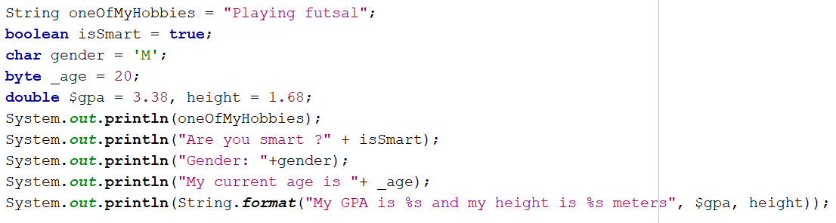

1. Run the program code that you have written, then observe the results

**Questions!**

1. Change the variable name so that the variable naming model is good and correct!
2. What is the function of %s in the statement below?

Is there anything you can use instead of %s? Name and explain it!

* 1. **Experiment 2: Use of Data Types**

**Experiment time: 40 minutes**

1. Open the Visual Studio Code
2. Create a new file, name it **ExampleDataTypeIDNumber.java**
3. Write the basic structure of the Java programming language which contains the **main()** function
4. Write the code below in **public static void main (String args [])**

1. Run the program code that you have written, then observe the results

**Questions!**

1. Explain why the **bloodGroup** does not display an "A"!
2. Explain the meaning of **byte distance = (byte) 130**! Then, explain why the results change when displayed!
3. In the syntax **float temperature = 60.50F;** remove the letter **F**, then run again. What happened?
4. Why does the result change when displaying weight values?
5. Explain the meaning of initializing **0x10** on **number** variables! What does it do?
   1. **Experiment 3: Use of Operators**

**Experiment time: 40 minutes**

1. Open the Visual Studio Code
2. Create a new file, name it **ExampleOperatorIDNumber.java**
3. Write the basic structure of the Java programming language which contains the **main()** function
4. Write the code below in **public static void main (String args [])**

1. Run the program code that you have written, then observe the results

**Questions!**

1. Explain in your opinion what is the difference between **x++** and **++x**!
2. What is the result of **int z = x ^ y;** do the calculations manually (you can use a calculator)!
   1. **Experiment 4: Case Study**

**Experiment time: 30 minutes**

*Pay attention to the Case Study below!*

Mr. Dani has a garage with a triangular shape. Mr. Dani plans to cement the ground floor of the garage so that it can be used to park motorbikes comfortably. Identify the input, output, and process to help Mr. Dani calculate the area of his garage, then implement it into the program code!

1. Identify input, output, and process

Input: base, height

Output: area

Process:

1. Input base, height
2. Calculate area = 1/2 *base *height
3. Output area
4. Identify the variables and data types used

|  |  |
| --- | --- |
| **Variables** | **Data Types** |
| base | int |
| height | int |
| area | float |

1. Implementation into program code

*Program code:*

1. Create a new file, name it **TriangleIDNumber.java**
2. Write the basic structure of the Java programming language which contains the **main()** function
3. Add the Scanner library at the top (outside) of the class



1. Create a Scanner declaration inside the **main()** function



1. Create **int** variables for the **base** and **height**, then a **float** variable for the **area**.



1. Write the command to input the base and height

1. Write down the command to calculate the area of a triangle



1. Display the contents of the **area** variable



1. Run the program code that you have written, then observe the results

**Questions!**

1. Explain why you have to declare Scanner in Experiment 4?
2. Explain the use of the program snippets below!





* 1. **Experiment 5: Case Study**

**Experiment time: 30 minutes**

*Pay attention to the Case Study below!*

Mrs. Dina is one of ABC bank customers who saved Rp. 5 million. The bank provides interest of 2% every year. Mrs. Dina saved for 5 years. How much interest and savings can you take now?

1. Identify input, output, and process

Input: base, height

Output: area

Process:

Input: initial savings amount, savings period

Output: interest, final savings amount

Other data: interest percentage = 0.02

Process:

1. Input the initial savings amount, savings period
2. Calculate interest = savings period * interest percentage * initial savings amount
3. Calculate the final savings amount = interest + initial savings amount
4. Interest output and final savings amount
5. Identify variables and data types

|  |  |
| --- | --- |
| **Variables** | **Data types** |
| init_sav_amount | int |
| sav_period | int |
| final_sav_amount | double |
| interest | double |
| interest_percent = 0.02 | double |

1. Implementation into program code

*Program code:*

1. Create a new file, name it **BankIDNumber.java**
2. Write the basic structure of the Java programming language which contains the **main()** function
3. Add the Scanner library at the top (outside) of the class



1. Create a Scanner declaration inside the **main()** function



1. Create **int** variables for the **base** and **height**, then a **float** variable for the **area**.
2. Create **int** variables for the **init_sav_amount** and **sav_period**, then **double** variables for the **final_sav_amount**, **interest**, and **interest_percent** according to the identification of variables and data types that has been done previously.

1. Write the command to input the **init_sav_amount** and **sav_period**

1. Write down the command to calculate **interest**



1. Write a command to calculate the **final_sav_amount**



1. Display the value of the **interest** and **final_sav_amount** variables



1. Run the program code that you have written, then observe the results
2. **Assignment**

Assignment Time: 120 minutes

Case Study 1:

* Ms. Jesi is an employee at PT. ABCD with a basic salary of Rp. 3,000,000/month. At PT ABCD, each employee receives a child allowance based on the number of children they have. The monthly child allowance is Rp. 150,000/child. In addition, 5% of their basic salary is deducted monthly for mandatory pension savings. Create a program to calculate Ms. Jesi's net salary each month, given that she has 3 children.
* Modify the program you created in case study 1 by converting the basic salary, monthly child allowance, and number of children into dynamic inputs.

Case Study 2:

* Mr. Jaka has land measuring 50 meters wide and 100 meters long. He plans to build two fish ponds: a circle with a diameter of 2 meters and a square with a side length of 2 meters. He will then plant grass on the remaining land. How much grass will Mr. Jaka plant?
* Modify the program you created in case study 2 by changing the width, length, diameter and sides into dynamic input!